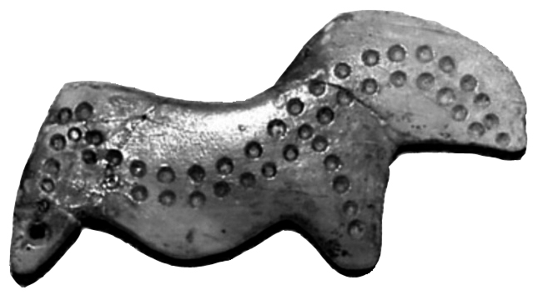

8-9 февраля 2016 г.

в Институте истории материальной культуры РАН состоится семинар Комиссии 8 «Верхний палеолит Евразии» Международного Союза доисторических и протоисторических наук по теме:

Сунгирь и стрелецкая культура в контексте раннего верхнего палеолита восточной Европы

Workshop of the Commission no. 8 (The Upper Paleolithic of Eurasia) of the UISPP
Institute for the History of Material Culture RAS, St. Petersburg

The Sungirian and Streletskian in the context of the eastern European early upper Paleolithic

Рабочий язык семинара – английский и французский (работа переводчиков не предполагается).

Monday, February, 7
9:00 Registration of participants
Morning Session
Chair: Vasilyev S.A.
Secretary: Zheltova M.N.

10:00 Lapshin V.A. Welcome from the Directorate of the Institute for the Material Culture History
10:05 Otte M. Welcome from the Commission no. 8 of the UISPP
10:10 Vasilyev S.A. Opening Remarks

GENERAL TOPICS
10:20 Otte M. Le Sungirien, première présence moderne en Europe
10:40 Zwyns N., Kuhn S.L. The Initial Upper Paleolithic in Eurasia: issues of definition and spatial-temporal distribution
11:00 Bosinski G. Sungir and Sungir-Streletskaya culture. Art before the Aurignacian

11:20 Coffee Break

11:40 Sinitsyn A.A. Streletskian in the context of East European Early UP: current state of the problem.

THE ORIGIN OF THE STRELETSKIAN
12:00 Bataille G. Buran-Kaya III, Level C (Crimea) and Kostenki 12, Layer III (Central Russia) in the context of the Streletskian and the Eastern Micoquian
12:20 Ocherednoy A.K., Vishnyatsky L.B., Voskresenskaya E.V., Nekhoroshev P.E. Betovo: new chronological evidence and an old hypothesis about the roots of the Streletskian

HUMAN REMAINS FROM SUNGIR AND KOSTENKI
12:40 Buzhilova A.P. Anthropological analysis of the human remains from Sungir and Kostenki 14: cause of the individual’s death in the context of burial rites
13:00 Mednikova M.B., Dobrovolskaya M.V. New approach to the study of biological adaptation: humans Sungir 1 and Kostenki 14
13:20 Dobrovolskaya M.V., Mednikova M.B. Concerning biological age of adult Sungir males: new histological study in the context of deliberate burials

13:40-15:00 Lunch

Afternoon Session
Chair: Sinitsyn A.A.
Secretary: Stepanova K.N.
SUNGIR
15:00 Gavrilov K.N. Sungir: the choice between Szeletian and Aurignacian
15:20 Reynolds N., Dinnis R., Higham T. Current practice and recent methodological advances in radiocarbon dating with reference to Sungir.
15:40 Gavrilov K.N., Lev S.Y., Higham T., Mischance E.N., Voskresenskaya E.V., Panin A.V., Zaretskaya N.E., Reynolds N., Eskova D.K. Recent field works on Sungir site and some preliminary results

16:00 Coffee Break

16:20 Seleznev A.B. Spatial structure of the 2nd and 3rd "dwellings" of Sungir. The case of stone primary knapping
16:40 Soldatova T.E. Characterizing the Early Upper Paleolithic bone industry from Sungir
17:00 Zhitenev V.S. Personal ornaments and ornamental pattern from Sungir in the Early Upper Paleolithic context of Eastern and Central Europe

17:30 Reception in the Paleolithic Department

Tuesday, February, 8
Morning Session
Chair: Gavrilov K.N.
Secretary: Larionova A.V.
STRELESKIAN ASSEMBLAGES IN KOSTENKI
10:00 Dudin A., Rodionov A. Lowermost cultural layers of Kostenki 1 in the context of the "Streletskian" sites in Kostenki-Borshchevo area
10:20 Dinnis R., Bessudnov A.A., Reynolds N., Dudin A.E., Sablin M.V., Sinitsyn A.A., Higham T. An overview of the Kostenki Streletskian, and new chronological data for Layer III of Kostenki 11
10:40 Girya E.Yu. The Streletskaya culture and the beginning of the Eastern Europe Upper Paleolithic
11:00 Haesaerts P., Sinitsyn A., Damblon F., van der Plicht J., Pirson S., Nigst P. New data on the radiocarbon chronology of the Streletskian at Kostenki (Voronezh region, Central Russia)
11:20 Coffee Break

11:40 Lisitsyn S.N., Hoffecker J.F., Holliday V.T. Сurrent research at Kostenki 12 (excavations 2015)

BEYOND KOSTENKI: STRELETSKIAN AND SIMILAR INDUSTRIES IN CENTRAL AND EASTERN EUROPE
12:00 Nerudova Z. Technology of the Szeletian (Moravian) leaf points
12:20 Oliva M. Les pointes triangulaires foliacées et le type de Míškovice
12:40 Pavlov P. Y. Sites of the Streletskaya culture in the context of Middle-to-Upper Paleolithic Transition in the North-East of Europe
13:00 Zakharikov A.P. Lithic industries with bifaces in the Early Upper Paleolithic of the Eastern Russian Plain East: the case of Nepryahino

13:20-14:30 Lunch

Afternoon Session
Chair : Lev S.N.
Secretary: Dolbunova E.V.

14:30 DEMONSTRATION OF LITHIC COLLECTIONS FROM KOSTENKI, SUNGIR AND OTHER SITES
GENERAL DISCUSSION
Otte M. Concluding remarks. Future activities of the Commission no. 8 of the UISPP

